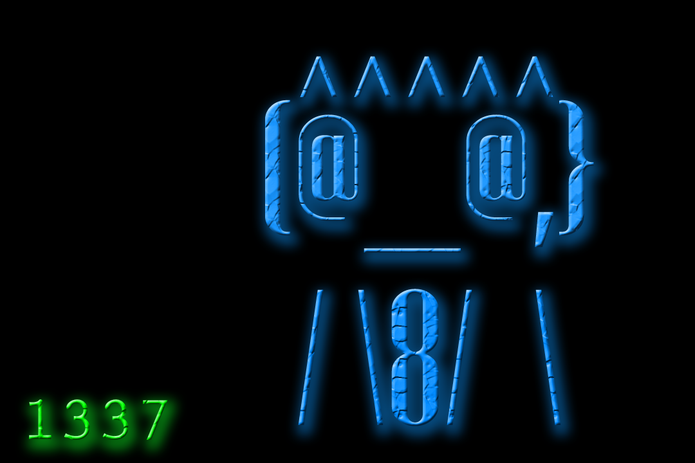

1337

“A Multiplayer FPS inspired by Hackers and Cube”

Author: Karle Sleith G00324919

Supervisor: Patrick Mannion

* Story

With the releases of the new “b33lz3bub” virus, millions of computers across the world have been taken hostage, with the intent of extorting their users, but one script kiddy had discovered that that its possible to erase the virus, but must transfer his consciousness to infected computers to do so.

* Inspiration

I’m taking inspiration on the art style for movies such as “Hackers” and “Cube”, I always found it funny in Hackers, a visual representation of “Hacking” is a 3D Spaceship destroying building like structures that represent “The Database”, and I wanted to make a game where hacking could be represented in a similar way.

In “Cube”, its about 5 people that have to transverse different rooms, that all look the same, but each has a unique but deadly trap, I would like to procedurally generate rooms, and have its own twist in battling enemies,

* Structure

The game will be designed in Unity using C#, I will also be using the .NET Framework to enable multiplayer, I also will be using a online database that will allow users to sign into the games and save progress, such as Statistics and Character Level,

The game will be from a “First Person Perspective”, It will be fast paced and “arcade-y” like DOOM, but keeping the procedurally generated worlds and Raid like Structure of more modern games like DESTINY.

The game will have a Health bar that will decrease when the player takes damage, and a score counter that will increment the longer that game goes on. The game will also save the players High Score. This Highscore counter will then been kept in a online leaderboard.

**Unity Community Edition 5.6**

**Unity** is a cross platform game engine developed by Unity Technologies, it is used to develop games for PC, Consoles, Mobile Devices and Websites.

As this will be first 3D game I will develop in Unity, I must learn various new functions that I can use to move characters on 3 axis, I will also learn the which methods I will need to implement when making the game compatable with multiplayer and online databases.